Skyline Audit Logging

# Introduction

This tutorial covers how to use the Skyline audit log. The audit logging system keeps track of all document modifications and displays them in an interactive grid, similar to the Document Grid. It benefits from all the features of the Document Grid, such as creating report templates, sorting by columns and editing cells, for example for adding a Reason to a log entry. One of the design goals of the audit log was to give anyone the ability to reconstruct the state of a document, given only the audit log and the original data. This makes it an invaluable tool for a Skyline user. As you will see, the audit log also makes the “Undo-Redo” feature more usable by providing more specific change messages and allowing you to undo changes in the audit log grid itself. To demonstrate important benefits of the audit log, this tutorial is based on the Absolute Quantification Tutorial, in which the absolute abundance of a target peptide is determined using Selected Reaction Monitoring (SRM) mass spectrometry by creating an external calibration curve with an internal standard heavy labeled reference peptide. This tutorial will be mostly focused on how to configure the audit log, how your actions are logged and how to read and work with the audit log. If you find you want to learn more about absolute quantification, you should refer to the Absolute Quantification Tutorial directly, which covers the topic in more detail.

# Getting Started

To start this tutorial, download the following ZIP file:

<https://skyline.gs.washington.edu/tutorials/AbsoluteQuant.zip>

Extract the files in it to a folder on your computer, like:

C:\Users\tobiasr\Documents

This will create a new folder:

C:\Users\tobiasr\Documents\AbsoluteQuant

The folder should contain a total of 9 RAW files, which you will import into Skyline later.

**Note:** In configuring Skyline for this tutorial, be sure to follow the steps below in the order presented to avoid creating audit logs of these initial setup steps.

* Now open Skyline and you will land on the **Start Page**.
* If you are using Skyline for the first time you will be prompted to select a default user interface. In the right-hand corner, ensure that the protein icon  is showing, indicating that Skyline is presenting the **Proteomics interface**. This can easily be changed in the future.
* Now click on the **Blank Document** tile.
* On the **Settings** menu, click **Default**.
* On the **File** menu, click **New**. When prompted whether you want to save your changes, click **No**.

**Opening the audit log**

First open the audit log by performing the following steps:

* On the **View** menu, choose **Other Grids** and click **Audit Log** (Alt + 4)

This should bring up the audit log in its default configuration as shown below:

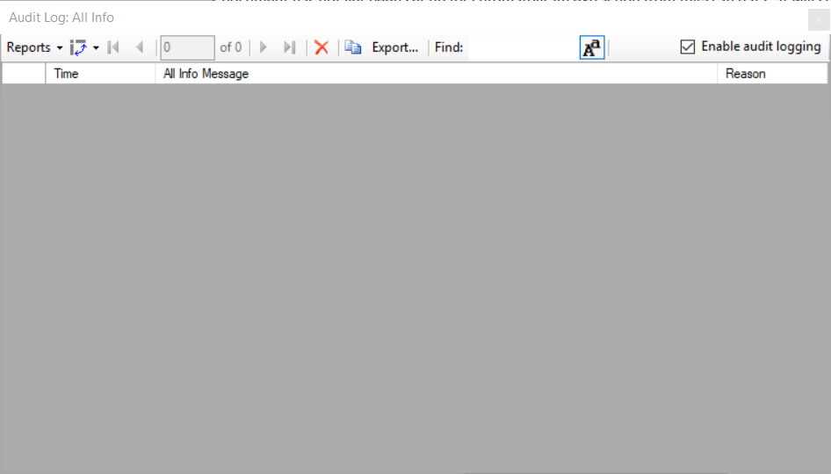

In the top right corner, you can see that audit logging is currently enabled, which is the default. By unchecking the box, audit logging can be disabled. Initially the audit log is showing its default column configuration, displaying the **Time**, **All Info Message**, and **Reason** columns. These columns will be explained in more detail and you will learn how to customize the columns in this grid. Keep this window open throughout the tutorial to observe how log messages appear as you interact with Skyline.

# Configuring Settings for inserting a new peptide

Before you insert a new peptide into the document, you need to configure the transition and peptide settings for this experiment as follows:

* On the **Settings** menu, click **Transition Settings**.
* Click the **Filter** tab.
* In the **Product ion selection** box, in the **From** dropdown list select **ion-3** and in the **To** dropdown list‘**last ion – 1**’.
* Click the **OK** button.

After you click **OK**, several messages will appear in the audit log window. Before taking a closer look at the audit log, first configure the peptide settings as follows:

* On the **Settings** menu, click **Peptide Settings**.
* Click the **Modifications** tab.
* Click the **Edit list** button next to the **Isotope modifications** list.
* Click the **Add** button
* From the **Name** dropdown list choose ‘Label:13C(6)15N(2) (C-term K)’.
* Click the **OK** button.
* Click the **OK** button in the **Edit Isotope Modifications** form.
* In the **Isotope modifications** list, check the new ‘Label:13C(6)15N(2) (C-term K)’ modification.
* Click the **OK** button.

# Reading the audit log

Now the audit log should look as follows:

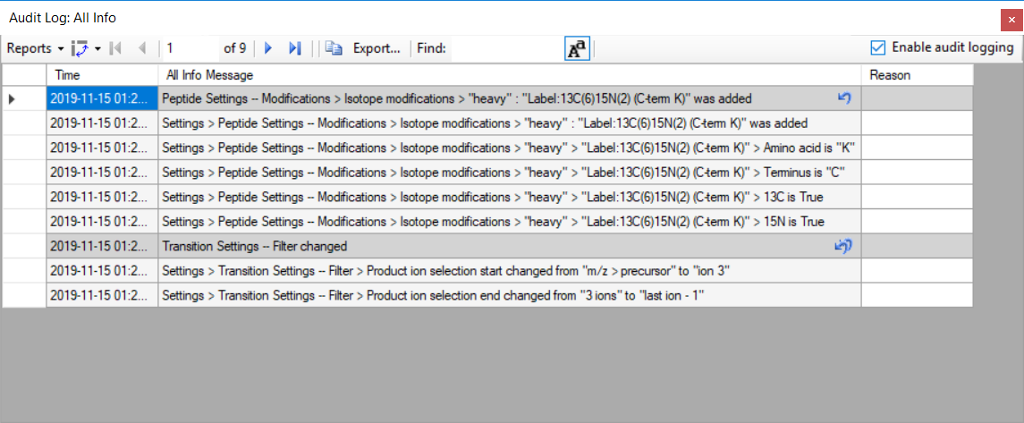

Each dark gray message and all messages below it until the next dark gray message or the end of the audit log represent a single document change. The transition settings and the peptide settings were changed, which creates a total of two **audit log entries**. By default, new messages appear at the top. Looking at the first entry when the transition settings were changed, the gray message is a one line summary of the entire entry: **Transition Settings – Filter changed**. This message is called the **Undo-Redo message**, because it is also used in the Skyline Undo-Redo list. To see this, return to the main Skyline window and click the small black arrow next to the Undo button to see the previous changes made to the Skyline document.

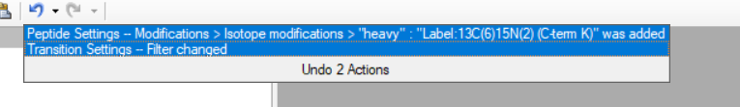

Before audit logging was introduced into Skyline, both messages here would only say **Changed settings**. Therefore, even if you have audit logging disabled, you can still benefit from it through improved Undo-Redo messages.

Return to the audit log window. The next five messages under the **Undo-Redo message** are the **All Info messages**, which describe every change in detail. Log messages will tell you exactly where a setting changed. For instance, the first message reads **Settings > Transition Settings – Filter > Product ion selection start changed from “m/z > precursor” to “ion 3”**. Recall that this is exactly where we navigated earlier to select the collision energy. The “greater than” symbols indicate that a menu item, while the “--" indicates that what follows is a tab, such as the **Prediction** tab. Next look at the message above, which describes the changes you made to the peptide settings. Note that the **Undo-Redo message** is very concise, telling you about the isotope modification you added. Looking below at the **All Info messages**, you can see that the audit log contains the exact definition of the modification you added, despite you not having configured it manually. This is in order for others to be able to reproduce those changes in the future, even if they do not have this particular modification in their Skyline instance, in which case they would have to create it manually.

# Undoing changes through the audit log

Again, looking at the audit log form, you should see that there is a single arrow next to the audit log entry at the top that describes the peptides settings changes. This is the same arrow as on the **Undo** button in the toolbar.

* Click the arrow in the Audit Log grid

This should make the audit log entry disappear and undo the change.

Return to the main Skyline window and you should see the **Redo** button on the toolbar, the previously grey arrow pointing to the right, turn blue.

* Click on the small black arrowhead to the right of it.

To see the dropdown list of changes you can redo, as shown below.

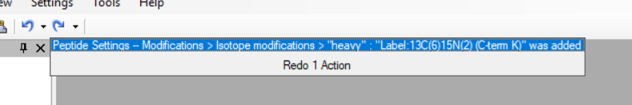

You can see the change you just undid through the **Audit Log** grid.

* Click on the change to redo.

Now return to the **Audit Log** grid and you will see that the audit log entry is back. Note that next to the other audit log entry are two undo arrows. This indicates that if you undo this change, all changes made after this one will also be undone. In this case undoing the transition settings change entry will also undo the peptide settings change entry. This exactly how Undo works when using the Undo dropdown list in the toolbar. You can undo back to a certain point in the document history, but you cannot revert a single change in the middle of the list. Note that once you close Skyline and open the document, those undo arrows will disappear from the audit log, since only changes made during your current Skyline session can be un- or redone, again consistent with the **Undo** and **Redo** buttons and menu items.

# Inserting a peptide sequence

Return to the Skyline window and perform the following steps:

* On the **Edit** menu, choose **Insert** and click **Peptides**.
* Copy “IEAIPQIDK”to the clipboard and paste it into the first **Peptide Sequence** cell.
* Copy “GST-tag”to the clipboard and paste it into the first **Protein Name** cell.

The form should look as follows:

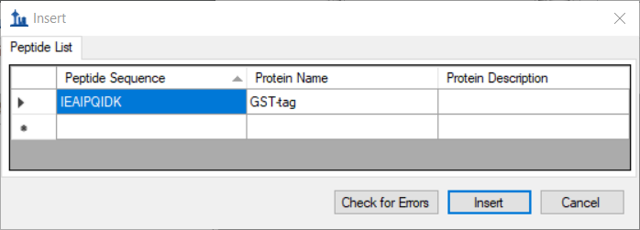

* Click the **Insert** button.

The **Targets** window should show the newly added peptide with a light and a heavy labeled precursor (use the + buttons to expand the view if necessary):

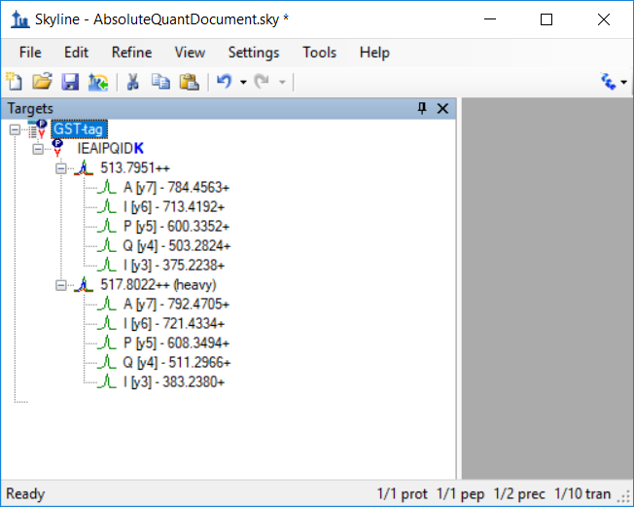

Note that the transition groups and transitions were expanded in the above screenshot. Refer to the **Audit Log** grid and you should see a new message indicating that you inserted the peptide IEAIPQIDK.  
There are no other detailed messages about this change. The audit log entry consists of a single audit log messages as shown below:

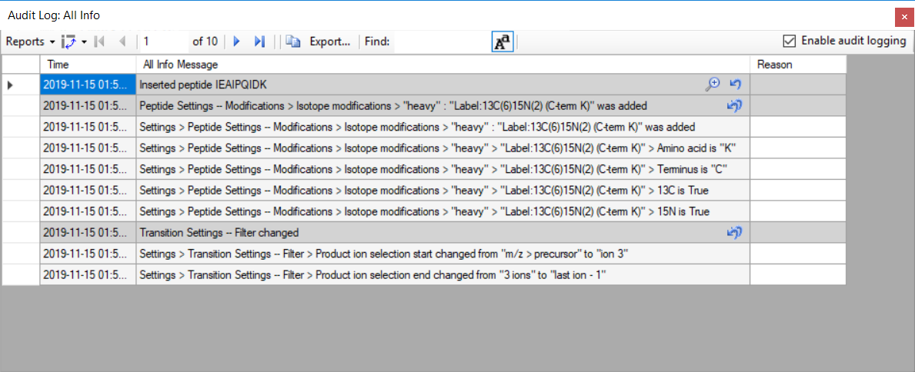

Note that there is a magnifying glass icon next to the new audit log entry. This appears whenever there is extra information associated with an audit log entry.

* Click on the magnifying glass.

This bring ups the **Audit Log Extra Information** window as shown below:

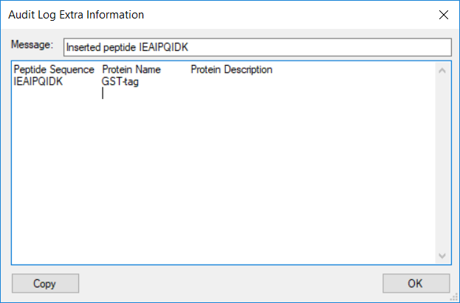

The extra information window shows all the information that was pasted into the grid when inserting the peptide, including the column header names. The cell values are separated by tab characters, which means one can copy entire rows from this window and copy them into the insert peptides dialog from earlier.

* Close the **Audit Log Extra Information** form by clicking **OK** andreturn to the audit log window.

Before continuing, you should save the document.

* On the **File** menu in Skyline, click **Save As**.
* Navigate to the AbsoluteQuant folder created earlier.
* In the File name field, enter “AbsoluteQuantDocument”.
* Click the **Save** button.

In Window Explorer, navigate to AbsoluteQuant folder in which you just saved the document. You should see a file called **AbsoluteQuantDocument.skyl** (along with **AbsoluteQuantDocument.sky** and .sky.view). If you do not see these file extensions, you may need to show file extensions in Windows Explorer. This .skyl file is the audit log. If you open it in a text editor like Notepad, you will see XML format text. If you are interested in the format, refer to the Audit logging paper. The audit logging file can be safely deleted at any time without damaging the document.

# Importing RAW files into Skyline

Next task is to import the RAW files from the SRM runs for this experiment:

* On the **File** menu, choose **Import** and click **Results**.
* Click the **Add single-injection replicates in files** option in the **Import Results** form.
* Click the **OK** button.
* In the **Import Results Files** form, navigate to the AbsoluteQuant folder and select all raw files.
* Click **Open** to import the files.
* Click **OK** to import the RAW files.

A few moments later, the RAW files should be imported, and Skyline should have created eight new replicates. Navigate to the audit log, which should now look as follows:

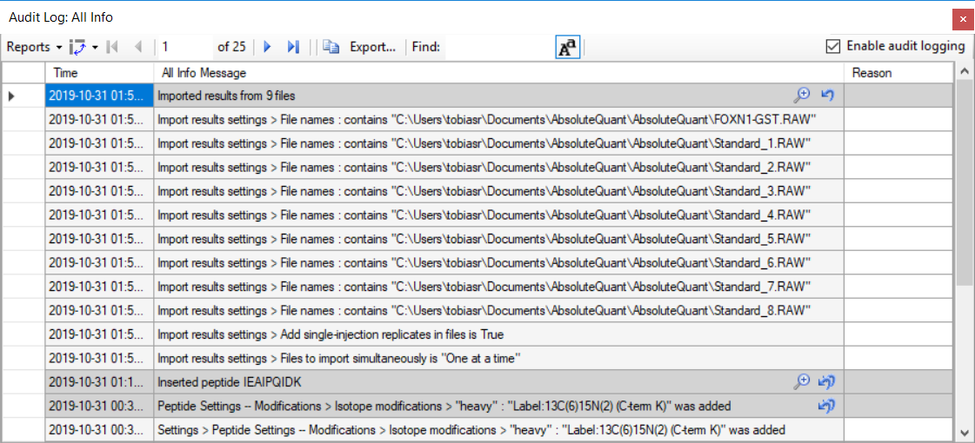

The audit log will not create copies of files that are imported, but rather just stores the paths of files that were imported. The first eight detailed messages are the paths of the nine raw files you imported. The second to last message is the option you set for importing replicates and the last message is another import setting that you did not set yourself, but it is still included in the log for reference.

Note that the primary entry again has a magnifying glass, which means it has extra information associated with it. This is always the case for a series of dialogs such as when importing results, where you configure a process that modified the document, instead of directly modifying the document like when changing the settings.

* Click on the magnifying glass to view the extra information:

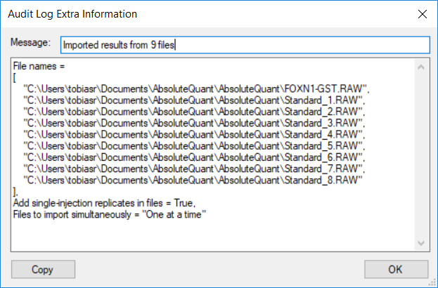

Click **OK** to close the window.

The extra information for wizards like the import results wizard does not contain any additional information, but rather a neatly formatted and more concise version of what is in the audit log. If you have any programming experience, this format might look familiar to you.

# Generating a Calibration Curve

**Configuring quantification settings:**

* On the **Settings** menu, click **Peptide Settings**.
* Click the **Quantification** tab.
* Change the **Regression Fit** dropdown list to **Linear**.
* Change the **Normalization Method** dropdown list to **Ratio to Heavy**.
* Type “fmol/ul” into the **Units** box.
* Click the **OK** button.

This generates the following audit log entry:

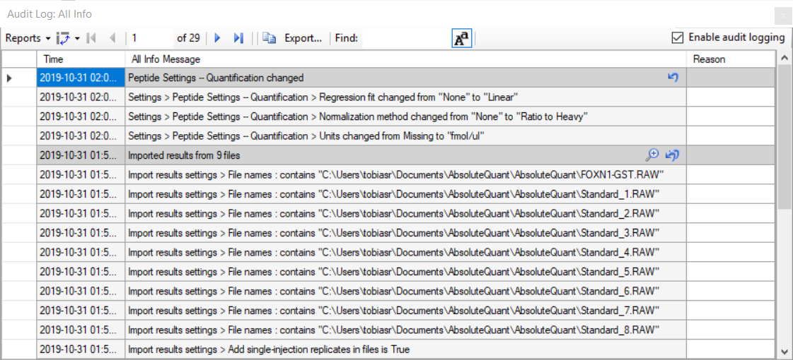

The changes made are listed under the heading **Peptide Settings – Quantification changed** and each step is captured in a detailed message describing it with enough detail that the step could be repeated.

# Specify the analyte concentrations of the external standards:

Next, you will specify the analyte concentration for each replicate using the **Document Grid** as follows:

* On the **View** menu, click **Document Grid**.
* In the top left of the Document Grid, click the **Reports** dropdown list and choose **Replicates**.
* In the row for Standard_1, select its **Sample Type**: **Unknown**.
* Copy the following data and paste it into the document grid to set each of the Standard replicates **Sample Type** to Standard and their **Analyte Concentrations**

|  |  |
| --- | --- |
| Standard | 40 |
| Standard | 12.5 |
| Standard | 5 |
| Standard | 2.5 |
| Standard | 1 |
| Standard | 0.5 |
| Standard | 0.25 |
| Standard | 0.1 |

The **Document Grid: Replicates** form should look like:

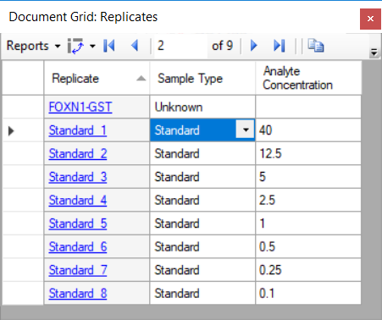

Review the **Audit Log** grid to see that it shows the following:

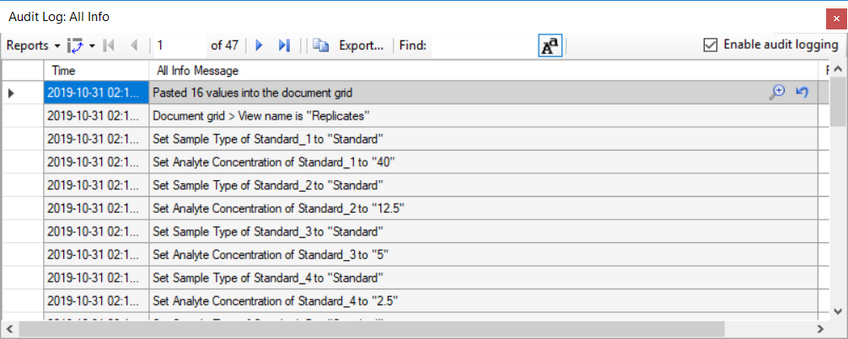

The Undo-Redo messages indicates that 16 values were pasted into the **Document Grid**. There are a total of 17 detailed messages. The first message tells us that the **Replicates** report was used. This is important because in order to reproduce this document grid change, you need to know what columns were present. The follow 16 messages describe each cell change, one for each of 8 changes in the **Sample Type** column and 8 in the **Analyte Concentration** column. Since you pasted data, this audit log entry again contains extra information.

* Open the extra information window by clicking on the magnifying glass icon.

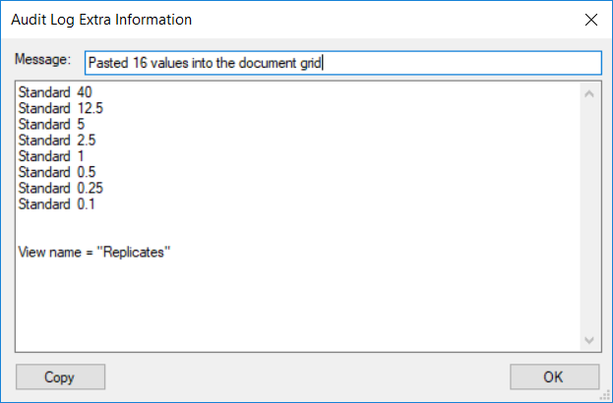

This displays a much more concise view of the data that was pasted into the document and again the data can be easily copied and pasted into another document. The report that was used is also indicated at the end of this extra information – in this case: **Replicates.**

* Click **OK** to return from the **Audit Log Extra Information** window back to Skyline.

# Adjusting integration boundaries

Next, you will look at the integration boundaries of the peptide in the FOXN1-GST sample:

* On the **View** menu, choose **Arrange** **Graphs** and click **Tabbed**.
* Click on the **FOXN1-GST** tab, or select the **FOXN1-GST** replicate in the box in the **Targets** window.
* Ensure that the peptide is selected in the **Targets** window.
* Now you should see the chromatogram of **IEAIPQIDK**in the **FOXN1-GST** sample.

By selecting either the light or heavy precursor in the **Targets** window you can see how well the integration boundaries capture the peak.

* Select the heavy precursor and zoom in on the peak by using the scroll-wheel on the x-axis.

You should see something like the following:

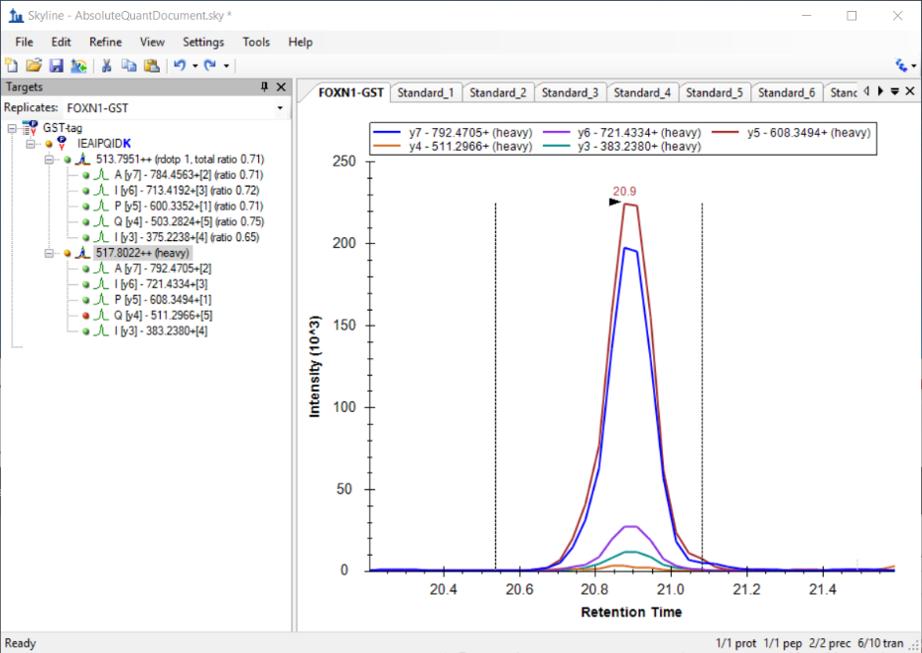

The integration boundaries look acceptable and changing them may simply add variance to the peak area calculations. However, one might want to set the end boundary slightly more to the right to approximately 21.1. Click and hold on the right integration boundary to drag it to approximately 21.1.

Switch to the **Audit Log** window and you should see that a new audit log entry appeared, as shown below:

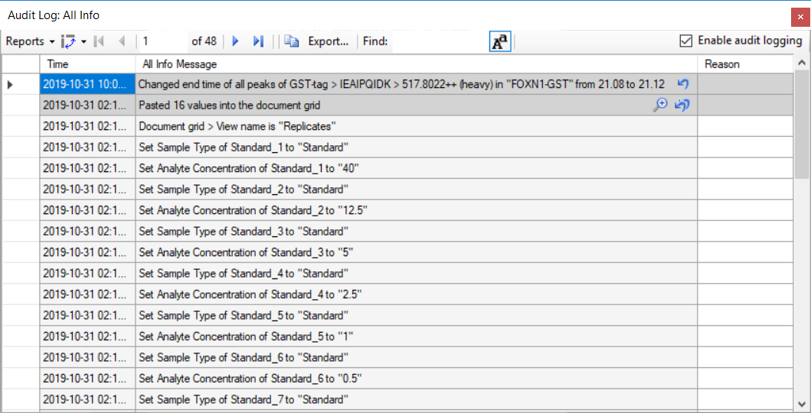

Note that when audit log describes a change related to an item in the **Targets** window, it uses a format similar to the one seen previously when changing document settings. Generally, the audit log will refer to items in the **Targets** windows by **Protein/Peptide List > Peptide > Transition group > Transition**.

When an outside person reads this audit log, this integration boundary change might seem arbitrary without any explanation.

* Click in the **Reason** cell next to the log message.
* Enter a Reason such as “*Changed end boundary to better fit peak*” and press **Enter**.

The audit log should now look like this:



# Calibration Curve

Next view the calibration curve configured earlier as follows:

* On the **View** menu, click **Calibration Curve**

The curve fits the first three points, but not for the points closer to zero. Use the scroll wheel to zoom in on the lower four points.

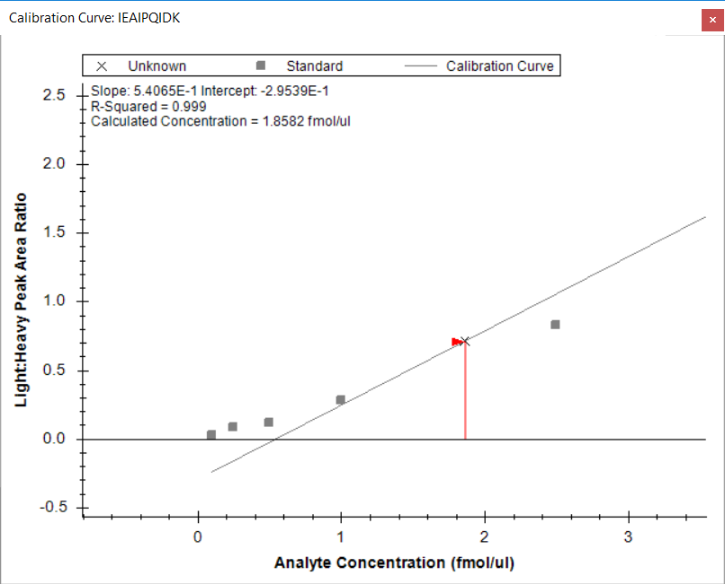

You can see that the last four points fall off the line, which indicates that they below the limit of detection for this peptide. To create a better fit for the remaining points, you can exclude these points from the regression as follows:

* For each of the lowest four points, right-click on the point and click **Exclude Standard**.

If you zoom out on the other four points, you should see that the curve fits them better now, and the R-Squared value in the top left corner of the graph should become 1.

Review the **Audit Log** grid and, you should see four new audit log entries, one for each point you excluded from the calibration:

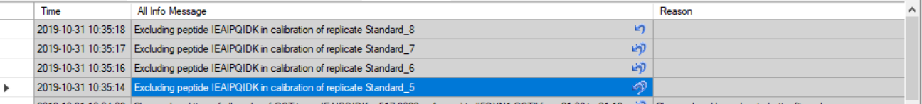

You will again add a reason to explain why the replicates were excluded.

* Click on any of the four reason cells and enter something like “*Excluded standard since it was below LOD*” and press **Enter**.

# Customizing the audit log

You now have a large audit log and it has become difficult to see all changes at once. The audit log is based on the document grid and can, therefore, be customized just like the document grid:

* In the top left corner of the audit log, click on the **Reports** drop down list.

There are three default reports you can select:

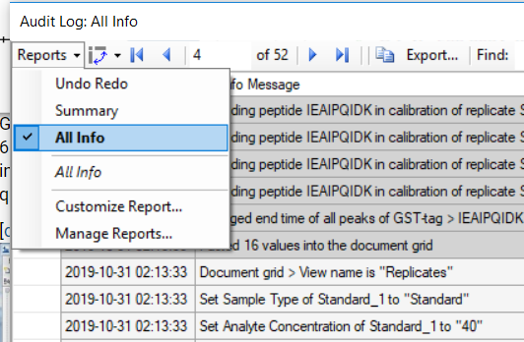

* Click on the **Undo Redo** report to select it.
* Adjust the column widths to make sure all cells are completely visible.

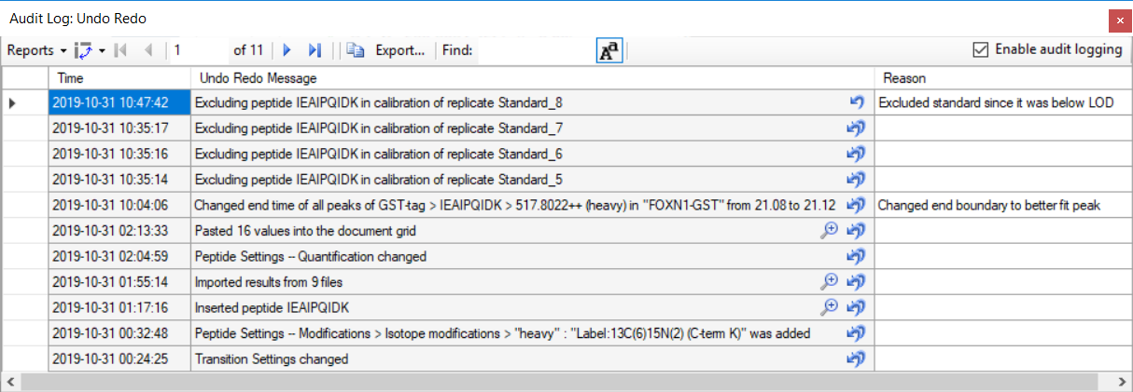

Now the audit log only displays the Undo Redo messages and not the detail messages, presenting a much better overview of what you changed in the document. Going from bottom to top, your changes can be summarized as follows:

* You first configured the Transition settings and Peptide settings to include the correct transitions and modifications.
* You inserted the peptide.
* You imported the results.
* You then started configuring the calibration curve, by configuring quantification settings.
* You pasted the standard and analyte concentration information into the document grid.
* You adjusted one of the peak boundaries and provided a reason for it.
* Finally, you excluded four standards from the calibration curve, again providing a reason.

Next, you will customize the audit log manually to show other columns:

* In the top left corner of the **Audit Log** window, click **Reports** and choose **Customize Report**.
* Check the **Skyline Version** and **User** columns in the left-hand list.
* In the **Report Name** field, enter ‘Custom Columns’.

The filled-out form should look like the following:

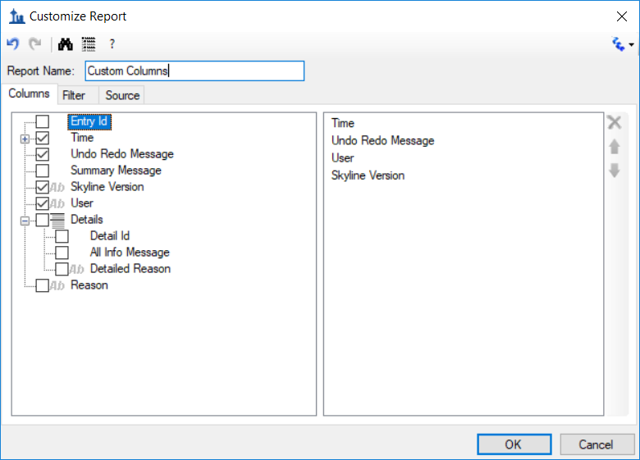

* Click the **OK** button.

The **Audit Log** should now look like the following, although you will have a different user name and you might be using a different Skyline Version.

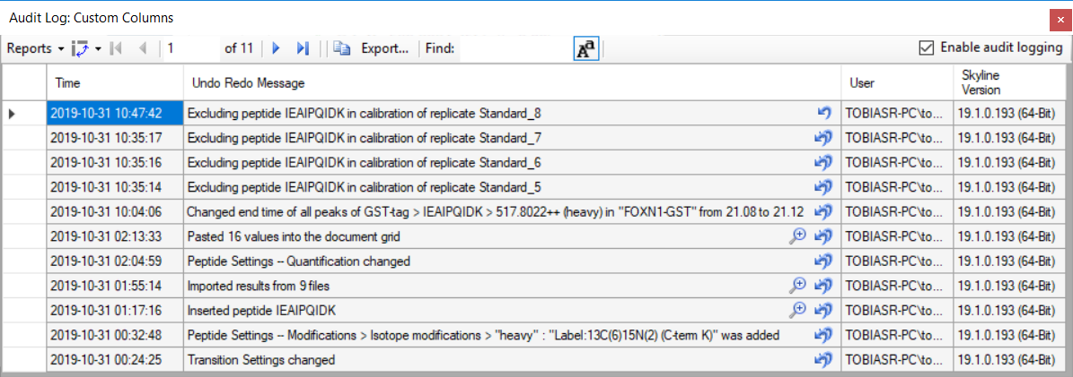

Below is list of all of the columns you can select and their meaning:

* **Time Stamp:** Time at which the change was made.
* **Undo Redo Message:** The most specific single line message describing the entire document change. This message will also be displayed in Skyline’s toolbar when clicking on the arrows next to the Undo-Redo arrows.
* **Summary Message:** Similar (and often the same) as the Undo Redo Message, but for certain messages shorter.
* **All Info Message(s):** A list of messages that describe the document change in detail.
* **User:** Identity of the user who made the change as authenticated by the local operating system.
* **Reason:** The reason for the change, which can be set by editing the cell in the audit log grid after the change was made. (Optional)
* **Detailed Reason:** A reason that can be set for each of the detailed “All Info messages”. (Optional)
* **Extra Info:** additional information, usually large amount of data pasted into the document. (Optional)

**+ Panorama (Rita)**

# Conclusion

This tutorial went through setting up an absolute abundance experiment to demonstrate how to use the audit log. The audit log keeps tracks of all changes you make to your document and is fully customizable. It is a powerful tool to reproduce the state of a document from scratch and can be useful when working on the same document with collaborators or when requesting troubleshooting help from the Skyline team.